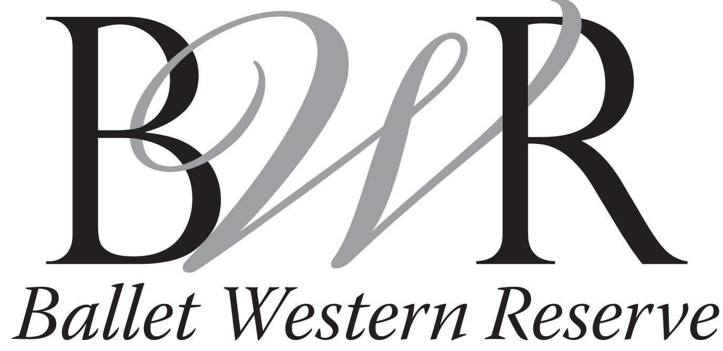

2023-2024 TUITION SCHEDULE

Non-refundable Registration Fees:
$35 for new students
$20 for current BWR students
$45 for current BWR families with more than two enrolled students

Tuition Rates: Per Semester Monthly Installments
(Fall Semester Sept. –Dec)
(Spring Semester Jan.-April)

30 Minute Class $237 $59.25
45 Minute Class $271 $67.75
1 Hour Class $328 $82
Over 1 Hour Class $351 $87.75
4-6 Classes $1,221 $305.25
7-9 Classes $1,293 $323.25
10 or More Classes $1,365 $341.25
* Payments made in monthly installments must be paid by the 7th of each month. A $10.00 late fee will be applied to all past due accounts.

Family Discounts:
2nd Child – 5% Discount on tuition for both dancers
3rd plus Child – 10% Discount on each dancer’s tuition

Adult Classes: $15 each

Recommended Number of Classes:
Ballet I & II- 2 - 3 Classes per Week
Ballet III & IV- 3 - 4 Classes per Week
Ballet V & VI- 4+ Classes per Week
Beginner Point must take at least 3 Ballet classes per Week

